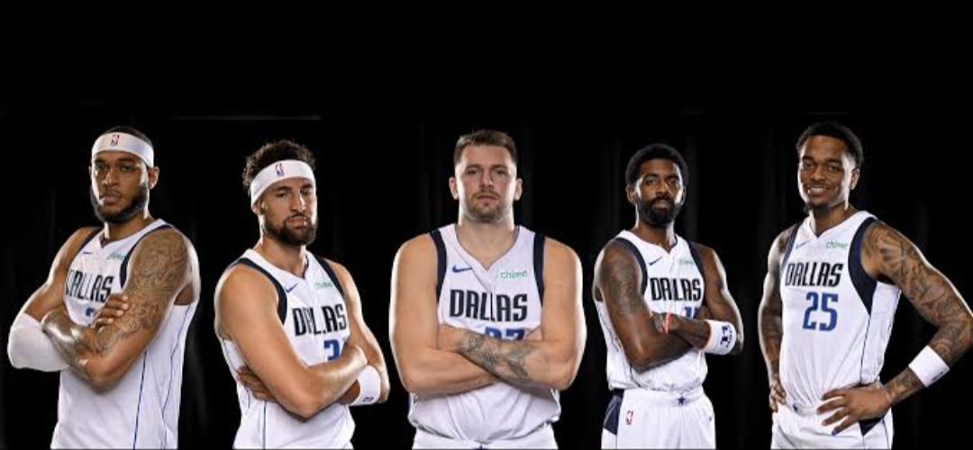

Dallas Mavericks Season Analysis

2024-2025 vs 2025-2026

- Purpose of the analysis
The goal behind this analysis is to study how the absence of an elite point guard may affect the overall performance of a basketball team in the modern world of basketball. The Dallas Mavericks are used as a case study to compare the team’s performance across two seasons and identify significant changes in their results, overall performance, ball distribution and consistency.

- Research Question
How did the absence of Kyrie Irving being in the top pool of the NBA’s elite point guards currently, affect the Mavericks’ performance during the 2025-2026 season compared with the 2024-2025 season?

- Introduction
A significant change in overall performance of the team from the 2024-2025 to the 2025-2026 NBA seasons was quickly noticed by fans and viewers. This analysis is setup to clarify what caused these observed changes in the team’s performance across the two seasons.

- Objective of the analysis
- Compare the Dallas Mavericks’ overall performance between the 2024-2025 and 2025-2026 seasons. For a clear and effective comparison, the following highly influencing indicators will be used:
- Wins
-Losses
-Points Per Game (PPG)
-Assists Per Game (APG)
-Turnovers Per Game (TOPG)
-Pace
-Offensive Rating (OR)
-Net Rating (NR)
- Examine the team’s consistency throughout each season using win/loss trends.
- Determine whether the statistical difference between the two seasons suggest a drop or an improvement in the team’s performance with respect to the absence of Kyrie Irving.
- Identify the areas of the team’s performance that were most affected, in order to adopt suitable changes in tactics for the upcoming season.

- Data Sources/ Data collection
For this analysis, all the data used was gotten from a world-wide rich data warehouse, SOFASCORE, which contains real time team data and statistics. After the data being collected, it was stored in spreadsheets to ease data cleaning and processing.

- Analytical Methodology
The 2024-2025 season will serve as the comparison season, while the 2025-2026 season will be used examined as the season in which Kyrie Irving was absent.
The analysis will use statistical comparisons and visualizations to identify changes between the two seasons. Charts will be used to visualize the differences in the team performance.
The results will then be interpreted to determine what these changes may indicate about the team’s performance without an elite point guard.

- Key Insights
1 – Overall Performance
The comparison between the 2024–2025 and 2025–2026 seasons shows a clear decline in the Dallas Mavericks’ overall performance. The team recorded fewer wins and more losses, indicating a reduction in its ability to consistently achieve positive results. Offensive efficiency and playmaking also changed, as reflected by variations in points and assists per game. Changes in turnovers further suggest that the team faced challenges with maintaining possession and creating efficient offensive opportunities. Offensive Rating and Net Rating, provide additional evidence of the decline in overall team efficiency.

2 – Playmaking
The assist-to-turnover analysis indicates a decline in the Mavericks' playmaking efficiency during the 2025–2026 season. A lower assist-to-turnover ratio suggests that the team generated fewer assists relative to the turnovers committed, reflecting less efficient decision-making and ball handling. This decline is particularly relevant to the team's point-guard situation, since playmaking and possession management are major responsibilities of the position. The result suggests that the absence of an elite point guard may have affected the team's ability to consistently create opportunities while protecting the ball.
3 – Offensive Efficiency
The season comparison shows a decline in the Mavericks' offensive efficiency during the 2025–2026 season. A reduction in points per game and Offensive Rating would indicate that the team became less efficient at converting its possessions into scoring opportunities. This suggests that the Mavericks experienced difficulties in producing points efficiently. The decline may be associated to changes in playmaking and offensive organization. The absence of an elite point guard could have contributed to these difficulties by reducing the team's ability to consistently create and organize offensive possessions.

4 – Ball Distribution
The assist and turnover analysis suggests that ball distribution became less effective during the 2025–2026 season. A decrease in assists combined with an increase in turnovers would indicate poorer ball movement and less efficient possession management. This could have reduced the team's ability to create open scoring opportunities and maintain offensive rhythm. Such a change is particularly significant when examining the impact of point-guard absence, as point guards often play a central role in organizing and distributing the ball.
5 – Consistency
The win/loss trend indicates that the Mavericks became less consistent during the 2025–2026 season. The fluctuation between wins and losses suggest that the team struggled to maintain a stable level of performance throughout the season. This inconsistency would have made it more difficult to build a strong winning record. The instability may also reflect difficulties in maintaining offensive organization and reliable playmaking throughout the season.

- Conclusion
The analysis shows that the absence of Kyrie Irving during the 2025–2026 season was associated with a noticeable change in the Dallas Mavericks' overall performance compared with the 2024–2025 season. Differences in wins and losses, scoring, assists, turnovers, and other team-performance indicators suggest that the team faced challenges in maintaining the same level of efficiency without an elite point guard.
Overall, the findings suggest that Kyrie Irving's absence had a significant negative impact on the Mavericks' performance, particularly in areas related to offensive production, playmaking, and consistency. However, the analysis does not fully establish that his absence was the main cause of the team's decline, since team performance can also be influenced by injuries, roster changes, coaching, opponents, and other factors.
Therefore, the analysis supports the conclusion that the absence of an elite point guard such as Kyrie Irving can have a substantial effect on a team's overall performance and offensive organization.

